*Florida International University*

*School of Computing and Information Sciences*

CIS 4911 - Senior Capstone Project

Software Engineering Focus

Final Deliverable

SkillCourt 3.0

Team # 13

**Team Members**

Wilfrido Rodriguez

Sergio Saucedo

**Product Owner**: Gummi Traustason

**Instructor**: Masoud Sadjadi

Copyright and trademark notices, restrictions on copying or distributing the documentation, information for contacting the issuing organization (reader’s comments), warranties, contractual obligations or disclaimers, and general warnings and cautions.

***Abstract***

*SkillCourt 3.0 is a skill-training simulator system for soccer players and coaches. This document will comprise of its design, new implementations, limitations and the project plan carried out with the purpose of updating the current functionalities from its last version (2.0) and greatly improving user experience.*

**Table of Contents**

**Introduction**

Current System

Purpose of New System

**User Stories**

Implemented User Stories

Pending User Stories

**Project Plan**

Hardware and Software Resources

Sprints Plan

*Sprint 1*

*Sprint 2*

*Sprint 3*

*Sprint 4*

*Sprint 5*

*Sprint 6*

*Sprint 7*

**System Design**

Architectural Patterns

System and Subsystem Decomposition

Deployment Diagram

Design Patterns

**System Validation**

**Glossary**

**Appendix**

Appendix A - UML Diagrams

*Static UML Diagrams*

*Dynamic UML Diagrams*

Appendix B - User Interface Design

Appendix C - Sprint Review Reports

Appendix D - Sprint Retrospective Reports

**References**

# Introduction

Soccer is the most played sport in the world. This sport attracts people from all ethnicities and backgrounds and joins them for the love of the sport. Those people who enjoy playing the sport, lack an interactive training facility where they can improve their soccer skills as well as have fun while they do it.

SkillCourt aims to solve this problem, since you do not require a highly qualified training staff to help you develop your soccer skills. With the help of SkillCourt, players as well as coaches will benefit from this solution. It will provide its users the ability to improve their skills, as well as sharpen a coach’s ability to design soccer drills. These routines will showcase the ability of cognitive sports learning as well as an adaptation to a whole new level of training.

This section explains the current system’s functionalities, limitations and constraints of SkillCourt 2.0. Followed by an overview of the new system, additional features and enhancements that will be made on SkillCourt 3.0.

## Current System

The current system’s purpose is to provide its users a simulator interface where they can play routines on the website. This simulator is the main product of this current release, and its focus was to provide users with the ability of going through default routines, as well as routines created by coaches. SkillCourt 2.0 allows coaches to create and edit custom routines, as well as assigned them to registered players.

The simulator provides live feedback of the player’s performance during a selected routine. This allows the user to observe how well they are doing, by means of the statistics shown.

SkillCourt 2.0 has a lot of potential, and there are some areas that could be refined and improved. Among the main limitations this system has, is the usability aspect of the website. It doesn't provide a clear objective of the website for first time users. The steps necessary to complete a routine seem ambiguous or not clear enough for first time users.

## Purpose of New System

The purpose of the new system is to enhance the current functionalities being offered by the current system and to provide a comprehensible guide to improve the user experience in the use of the Simulator, and Routine Wizard. SkillCourt 3.0 will consist of better visuals and interfaces that will provide interactive step-by-step guides to users explaining the usability of the product. Since the intended audience are soccer players, the new system will be able to show real-life demonstrations of the skills that are being worked on in the simulator and provide statistical feedback based on a group of routines already performed.

The new system will also improve the routine creation process for Coach Users by reducing the amount of steps needed to create a complete routine, and provide interactive help to make the process more user friendly.

# User Stories

The purpose of this section is to provide a description of all the user stories in the product backlog of the third release of SkillCourt. The user stories are divided into two sub-sections. The first subsection contains all the implemented user stories for the new system, followed by the stories that are carried over from the previous release, including stories not implemented during the development of this project.

## Implemented User Stories

**User Story # 1 - Enhance Website Homepage**

Homepage should be more dynamic, making it more visually appealing to its users. The UI will be revamped and improved.

**User Story #2 - Interactive Summary Table**

As a first time user, the home page should contain interactive content providing the main aspects’ information about SkillCourt.

**User Story #3 - Player Tutorial Interactive Guide**

As a player user, I should be able to click on help in the simulator page for an interactive tutorial to guide over the different options on how to play the simulator.

**User Story #4 - Coach Tutorial Interactive Guide**

As a coach user, I should be able to click on help in the wizard page for an interactive tutorial to guide over the process of creating a routine.

**User Story #5 - Enhance About Page**

About page should be more dynamic and organized, making it more visually appealing to its users.

**User Story #6 - Real-Life Demonstration Video**

As a user, I should see a real-life demonstration video showing the idea of SkillCourt’s vision.

**User Story #7 - Interactive Team Members Display**

As a user, I should be able to see the team members who has been involved in SkillCourt’s releases.

**User Story #8 – Real-Life Demonstration Video and Interactive Summary Table Unification**

As a user, I should be able to see the real-life video as a tab inside the interactive table in the homepage.

**User Story #9 – Home and About Page Updated Information**

As a user, the information I read should be the most updated description about SkillCourt.

**User Story #10 – Help Button Interaction**

As a logged-in user, when I click the help button, it should start the corresponding interactive tutorial based on the page that’s showing (Simulator or Wizard).

**User Story #10 – Design MVC Architectural pattern in SkillCourt System**

Current system lacks an architectural design pattern. The system will be redesigned using a MVC architectural design pattern to reduce complexity and allow to make the system less buggy, easier to maintain, and reusable. Models, Views, and Controllers will drive all the requests in the website. Allowing future developers to scale, and add more functionality with ease.

**User Story #11 – Create Dispatcher class to handle all requests in the system**

As a user, when I request a page. The system would redirect us to the appropriate page based on the controller and action requested. The user will be able to access the different pages, and functionalities of the SkillCourt system.

**User Story #12 – Allow Users to add favorite soccer teams**

As a user, I should be able to add my favorite soccer teams by accessing the profile page and accessing the Various Info tab. In here I will have the ability of adding multiple teams at the same time, as well as removing already added teams. This will allow the user to keep a list of soccer teams to follow and to add or remove teams as preferred.

**User Story #13 – Create a profile page for users**

As a user of SkillCourt. I will be able to access a dynamic profile page. In this page, i will be able to see information about my Personal Information, Athletic profile, and Various Info. I will see information messages based on the completion of the different sections of the profile page. Which will alert the user of important information about the site.

**User Story #14 - Display list of all the existent players in the SkillCourt database**

As a Coach user, I will be able to see a list of all the registered players in the SkillCourt system. This will allow Coaches to have a visual representation of the different types of players registered on the site. This list will provide the Coach details about a player such as, First Name, Last Name, Username, Email, Position, and Coach Information if any.

**User Story #15 - Allow Coach users to search for players using filters**

As a coach user, I will be able to search Players based on different criteria. Search users by First Name, Last Name, Username, Email Address, Position, and also return all the signed players for the current Coach.

**User Story #16 - Allow Coach users to sign players from the search results page**

As a coach user, after I have searched for players. I will be presented with a list of players whom have matched the input filter. In this list, based on the player’s status, I will be able to sign those players whom are Free. The page will reload after signing a player, and it will display a status of signed.

**User Story #17 - Allow Coach users to release players from the search results page**

As a coach user, I will be able to release players from the search page. I will be able to search for players to release based on the presented criteria of First Name, Last Name, Username, Email Address, Position, or all of my signed players. I will be able to click on the RELS button on the list. After clicking this button, the list will reload, and it will display the new status of the player of FREE.

**User Story #18 - Allow Coach users to assign routines to signed Players**

As a coach user, I will be able to assign routines to my signed players. I will be able to access the routines page from the top navbar. I will be presented a list of all of my routines, from which I will be able to click on assign and directly assign the selected routine to a selected signed player from the modal displayed. The modal will close, and it will show the updated list of assigned players to the selected routine.

**User Story #19 - Allow Coach users to unassigned routines from signed Players**

As a coach user, I will be able to unassigned players from routines that I have already assigned players to. I will be able to access the routines page from the top navbar. I will be presented with a list of routines which I have previously created and assigned players to. I will be able to click on the unassigned button, and click unassigned on the players I want to unassign from the selected routine.

**User Story #20 - Allow Coach users to edit created routines**

As a coach user, I will be able to edit routines I have previously created. I will have the option to edit custom or default routines. I will be able to access the routines page from the top navbar. I will be presented with a list of custom and default routines to choose from. I will be able to click on a routine, and click on the edit button. I will be redirected to the wizard page, where i will be able to edit the selected routine. Once I have finished editing such routine, I will be taken back to the Routines page.

**User Story #21 - Allow Coach users to delete unassigned created routines**

As a coach user, I will be able to delete routines whom are not currently assigned to any Players. I will be able to access the routines page from the top navbar. I will be able to click on a routine which is not assigned to any players, and click on the delete button. This will refresh the list of default and custom routines, and will show the routines minus the routine just deleted.

**User Story #22 - Allow Coach users to create custom/default routines**

As a coach user I will be able to create custom and/or default routines. I will be able to access the Wizard page from the top navbar of the page. I will be able to choose either Custom or Default routines to create. After creating either or, I will be redirected to the Routines page to display the newly created routines.

**User Story #23 - Create controllers, models and views for the Routines page**

Following a MVC architecture design pattern. The routines page will be created with a model representing a Routine and a collection of such routines. A controller, which will decide whether a routine has been requested and which routines to display. The views will display the requested routines to the actor of the system.

**User Story #24 - Create controllers, models, and views for the Players page**

Following a MVC architecture design pattern. The player’s page will be created with a model representing players and a collection of requested players. The controller will handle requests for certain players based on query filters. The views will display the requested players based on the actor’s interaction with the system.

**User Story #30 - Organization of User Stories from Initial Requirement Analysis**

List of user stories in product backlog.

**User Story #31 – Initial Requirement Analysis**

[Initial Feasibility Study](https://fiu-scis-seniorproject.mingle.thoughtworks.com/projects/skillcourt/cards/562)

**User Story #32 – Research New Aspects of Existing Project**

Familiarize with Processing.js and Parse.js

**User Story # 33 – Design UI**

Design the look of the User Interface of SkillCourt

**User Story # 34 – Video Modifications**

As a user, I should see the new logo in the video and the simulator layout on top to better see the effect of the pad

## Pending User Stories

**User Story #25 - Identifying first time users**

As a user, the website should give me the option to choose between first time user or returning user, and record my decision.

**User Story #26 - Enhance Player Simulator**

Improve simulator interface, making it more visually appealing to players

**User Story #27 - Enhance Coach Routine Wizard**

Coach routine wizard will provide a simple and straightforward approach to the creation of routines

**User Story #28 - Implementing statistics in Simulator**

As a player user, I should be able to see my statistics about performances, best times, best accuracy, rankings in terms of routines, etc. All of these stats stored to the user’s profile.

**User Story #29 - Resemblance of routines to real life**

As a player user, I should be able to see a real life example of the routine to connect the skills being worked on the simulator.

# Project Plan

As part of the project’s development process, we have created a structured and detailed plan to organize and divide our work. Since the methodology selected is Agile Scrum, our project plan is divided into seven two-week Development Sprints and a final one-week Release Sprint. During the first five Sprints, the team is dedicated to retire User Stories from the Product Backlog depending on the priority of each. The final Sprint is dedicated to prepare all the materials for the Product Showcase.

## Hardware and Software Resources

The hardware needed for the third release of SkillCourt includes an Android device with Bluetooth capabilities, and an Arduino Microcontroller with a Bluetooth module. Two computers are also vital to the development process each use by each developer.

As a tool for project management and team collaboration, Mingle from ThoughtWorks was used and for version control and source code management, we selected GitHub.

The system is divided into several subsystems, which requires a wide variety of software resources. The SkillCourt website was developed using HTML, CSS, JavaScript, PHP, JQuery and AJAX. A XAMPP web server was also needed to host the website during development stages. For production, Amazon Web Services EC2 is used to host the SkillCourt system. Parse Cloud is used as a Back-end Service, not only offering Cloud access to the data model but also Application Analytics and push notification support.

Some changes were necessary to the Android Application and Arduino microcontroller, which requires the use of Android Studio and Arduino Software. Part of the project was also directed towards improving the User Interface of the website, which required the use of Photoshop and Adobe Premiere Pro for the video editing and CGI effects.

## Sprints Plan

### Sprint 1

(08/31/2015 - 09/11/2015)

**User Story #31 - Organization of User Stories from Initial Requirement Analysis**

***Tasks***

* List of user stories in product backlog

***Acceptance Criteria***

* List of user stories in product backlog

***Modeling***

None

**User Story #32 – Initial Requirement Analysis**

***Tasks***

* [Initial Feasibility Study](https://fiu-scis-seniorproject.mingle.thoughtworks.com/projects/skillcourt/cards/562)

***Acceptance Criteria***

* What is the scope of this release
* What is the system supposed to do
* What are the high level requirements

***Modeling***

None

**User Story #33 – Research New Aspects of Existing Project**

***Tasks***

* Familiarize with Processing.js
* Familiarize with Parse.js

***Acceptance Criteria***

* Complete knowledge of the frameworks used in the project
* Basic understanding of the use of these frameworks

***Modeling***

None

### Sprint 2

(09/14/2015 - 09/25/2015)

**User Story # 34 – Design UI**

***Tasks***

* Design the look of the User Interface of SkillCourt.
* We will design the new look of the UI for the home page

***Acceptance Criteria***

* This will be discussed with product owners, in order to have our ideas validated by the feedback of Gummi and Jaime

***Modeling***

None

**User Story # 1 - Enhance Website Homepage**

***Tasks***

* [Add new logic to login component](https://fiu-scis-seniorproject.mingle.thoughtworks.com/projects/skillcourt/cards/597)
* [Design the layout and look of the new homepage](https://fiu-scis-seniorproject.mingle.thoughtworks.com/projects/skillcourt/cards/595)
* [Connect the login interface with the database to initiate the connection of the login](https://fiu-scis-seniorproject.mingle.thoughtworks.com/projects/skillcourt/cards/592)
* [Design the footer of the page](https://fiu-scis-seniorproject.mingle.thoughtworks.com/projects/skillcourt/cards/591)
* [Design the new Body of the page](https://fiu-scis-seniorproject.mingle.thoughtworks.com/projects/skillcourt/cards/590)
* [Design the new Body of the page](https://fiu-scis-seniorproject.mingle.thoughtworks.com/projects/skillcourt/cards/590)

***Acceptance Criteria***

* When visiting the website as a first time user, or returning user. The purpose of the website should be clear enough to understand what it is intended to be used for.

***Modeling***

None

### Sprint 3

(09/28/2015 – 10/09/2015)

**User Story #6 - Real-Life Demonstration Video**

***Tasks***

* [Add video tag to homepage](https://fiu-scis-seniorproject.mingle.thoughtworks.com/projects/skillcourt/cards/604)
* [Upload video to hosting service](https://fiu-scis-seniorproject.mingle.thoughtworks.com/projects/skillcourt/cards/603)
* [Synchronize all three layout](https://fiu-scis-seniorproject.mingle.thoughtworks.com/projects/skillcourt/cards/602)
* [Real-life representation editing](https://fiu-scis-seniorproject.mingle.thoughtworks.com/projects/skillcourt/cards/601)
* [Real-life representation of simulation](https://fiu-scis-seniorproject.mingle.thoughtworks.com/projects/skillcourt/cards/600)
* [Simulator frame inside video](https://fiu-scis-seniorproject.mingle.thoughtworks.com/projects/skillcourt/cards/599)
* [Phone layout frame inside Video](https://fiu-scis-seniorproject.mingle.thoughtworks.com/projects/skillcourt/cards/598)

***Acceptance Criteria***

* A representation of the simulator in real life. A potential prototype vision of what these routines will look like in real life.

***Modeling***

None

**User Story #13 – Create a profile page for users**

***Tasks***

* [Create the setting page](https://fiu-scis-seniorproject.mingle.thoughtworks.com/projects/skillcourt/cards/608)
* [Create the quick information pane](https://fiu-scis-seniorproject.mingle.thoughtworks.com/projects/skillcourt/cards/607)
* [Create the profile page](https://fiu-scis-seniorproject.mingle.thoughtworks.com/projects/skillcourt/cards/606)

***Acceptance Criteria***

* The user will be able to access their account information
* The user will be able to change its account settings
* The user will be able to add their favorite soccer teams, as well as their social media accounts.

***Modeling***

None

**User Story #12 – Allow Users to add favorite soccer teams**

***Tasks***

* Allow the user to input their favorite teams

***Acceptance Criteria***

* These teams will have the ability of being removed
* These teams ability to add more teams as needed

***Modeling***

To view the sequence diagrams please refer to Appendix A.

**User Story #2 - Interactive Summary Table**

***Tasks***

* [Implement JavaScript for transitions between views when tab are clicked](https://fiu-scis-seniorproject.mingle.thoughtworks.com/projects/skillcourt/cards/618)
* [Create different views that will show the corresponding information](https://fiu-scis-seniorproject.mingle.thoughtworks.com/projects/skillcourt/cards/617)
* [Added CSS Styles](https://fiu-scis-seniorproject.mingle.thoughtworks.com/projects/skillcourt/cards/616)
* [Design table/graphics](https://fiu-scis-seniorproject.mingle.thoughtworks.com/projects/skillcourt/cards/615)
* [Gather Information](https://fiu-scis-seniorproject.mingle.thoughtworks.com/projects/skillcourt/cards/614)

***Acceptance Criteria***

* Approved by product owners at meeting

***Modeling***

To view the sequence diagrams please refer to Appendix A.

**User Story #10 – Design MVC Architectural pattern in SkillCourt System**

***Tasks***

* Review what models, controllers, and views will be needed.
* This will continue through the development of the project.
* Design a high level overview of the different pages that will be needed

***Acceptance Criteria***

* The SkillCourt site will provide the user with a single entry point, from which the system will then redirect and control the user’s actions.

***Modeling***

To view the sequence diagrams please refer to Appendix A.

**User Story #11 – Create Dispatcher class to handle all requests in the system**

***Tasks***

* Develop a class called Dispatcher which will deal with all the requests coming in from the user. This dispatcher will determine which controllers to call, and what actions to perform.
* Implement an auto load class, which will include the needed classes as they become needed

***Acceptance Criteria***

* The dispatcher will control the flow of actions in the site. If a page is requested, the dispatcher will call the corresponding controller and give it the right action.

***Modeling***

None

### Sprint 4

(10/12/2015 – 10/23/2015)

**User Story #5 - Enhance About Page**

***Tasks***

* Create layout separation
* CSS style modifications

***Acceptance Criteria***

* Appealing Layout to display SkillCourt’s Introduction, Challenge, and Solution
* Easy to read for users.

***Modeling***

None

**User Story #7 - Interactive Team Members Display**

***Tasks***

* JavaScript to display team members who have collaborated in the SkillCourt project

***Acceptance Criteria***

* Easy implementation.
* Able to be customized.

***Modeling***

To view the sequence diagrams please refer to Appendix A.

**User Story #8 – Real-Life Demonstration Video and Interactive Summary Table Unification**

***Tasks***

* Interactively change between live demo and description of SkillCourt by using tabs instead of scrolling down.

***Acceptance Criteria***

* Have Video appear in one tab as the different aspects of SkillCourt defined in the Interactive Summary Table.

***Modeling***

To view the sequence diagrams please refer to Appendix A.

**User Story #20 - Allow Coach users to edit created routines**

***Tasks***

* Implement an AJAX function which will send the requested routine to be edited to the corresponding handler
* Design a handler which will update the routine’s information in the database.
* Implement a function which will return the user to the Routines page once the editing has been completed

***Acceptance Criteria***

* The user will be able to edit his/her previously created routines
* It will also redirect the user back to the routines page after the editing has been completed.

***Modeling***

To view the sequence diagrams please refer to Appendix A.

**User Story #21 - Allow Coach users to delete unassigned created routines**

***Tasks***

* Implement an AJAX function which will send a request to the appropriate controller to delete the custom or default routine from the database.
* Implement a refresh function to load up the list of routines reflecting the updated information

***Acceptance Criteria***

* The user will be able to delete only the routines whom do not have any players assigned to them.
* The list of routines will display the deletion by decrementing the list of routines by one.

***Modeling***

None

**User Story #22 - Allow Coach users to create custom/default routines**

***Tasks***

* Implement a new interface for the wizard and its respective custom options pane
* Implement a default pane with predefined value for the default routines
* Implement AJAX requests to handle the creation an error detecting of newly created routines.

***Acceptance Criteria***

* The user will be able to create default and custom routines
* The user will be able to give names and descriptions to the routines they wish to create

***Modeling***

To view the sequence diagrams please refer to Appendix A.

### Sprint 5

(10/26/2015 – 11/06/2015)

**User Story #9 – Home and About Page Updated Information**

***Tasks***

* Update all information according to changes in layout

***Acceptance Criteria***

* Product owners to approve updated description of SkillCourt’s vision, and different aspects of the system.
* Users not logged in should be able to grasp the main concept of SkillCourt.

***Modeling***

None

**User Story #14 - Display list of all the existent players in the SkillCourt database**

***Tasks***

* Allow the user to search for a player to sign based on 5 different search criteria or none
* It will display user records by rows displaying the following information: First Name, Last Name, Email Address, Position, Status, Actions.
* Status will either be FREE or SIGNED
* Actions will either be SIGN, or Show Coach, according to whether this user is signed or free.

***Acceptance Criteria***

* Player Filters: First Name, Last Name, Email Address, Position

***Modeling***

To view the sequence diagrams please refer to Appendix A.

**User Story #15 - Allow Coach users to search for players using filters**

***Tasks***

* Design different filters to be used
* Implement the search functionality by creating methods which deal with the different filter supplied

***Acceptance Criteria***

* The user will be able to search for players based on 5 different criteria
* The user will be presented with a list of the queried players

***Modeling***

To view the sequence diagrams please refer to Appendix A.

**User Story #16 - Allow Coach users to sign players from the search results page**

***Tasks***

* Display all the users to the coach whom are not coaches
* Allow the Coach to sign those players whom meet his criteria

***Acceptance Criteria***

* Coach is able to sign players who meet his criteria

***Modeling***

To view the sequence diagrams please refer to Appendix A.

**User Story #17 - Allow Coach users to release players from the search results page**

***Tasks***

* Implement AJAX calls on the interaction of the user with the browser. This will allow the system to know a request has been made
* Implement a refresh of the list mechanism to display the new status of the player

***Acceptance Criteria***

* The user will be able to release previously signed players
* The page will load and refresh the list of the just modified player

***Modeling***

To view the sequence diagrams please refer to Appendix A.

**User Story #24 - Create controllers, models, and views for the Players page**

***Tasks***

* Implement Models, Views and Controllers for the Routines page

***Acceptance Criteria***

* There will be an interaction between the model views and controller of the Routines page

***Modeling***

None

### Sprint 6

(11/09/2015 – 11/20/2015)

**User Story #3 - Player Tutorial Interactive Guide**

***Tasks***

* Implement Intro.js
* Create custom JavaScript functions
* Create ID tags to guide tutorial to the correct space
* Write brief descriptions of each option provided

***Acceptance Criteria***

* Simulator Tutorial should start when clicking on the help tab
* Simulator Tutorial should describe all the features available.
* When clicking on the Help tab, the user should only be able to click where the Tutorial is instructing them to.
* Everything should go back to normal usage when the tutorial is canceled or finished.

***Modeling***

To view the sequence diagrams please refer to Appendix A.

**User Story #18 - Allow Coach users to assign routines to signed Players**

***Tasks***

* Implement an AJAX call function to update the Assigned Routines class in the database.
* Implement a refresh function to load up the list of routines reflecting the updated information

***Acceptance Criteria***

* The user will be able to assign routines to previously signed players

***Modeling***

To view the sequence diagrams please refer to Appendix A.

**User Story #19 - Allow Coach users to unassigned routines from signed Players**

***Tasks***

* Implement an AJAX call function to update the Assigned Routines class in the database.
* Implement a refresh function to load up the list of routines reflecting the updated information

***Acceptance Criteria***

* The user will be able to unassigned routines from a routine with existing players assigned to it

***Modeling***

To view the sequence diagrams please refer to Appendix A.

**User Story #23 - Create controllers, models and views for the Routines page**

***Tasks***

* Implement Models, Views and Controllers for the Routines page

***Acceptance Criteria***

* There will be an interaction between the model views and controller of the Routines page.

***Modeling***

None

### Sprint 7

(11/09/2015 – 11/20/2015)

**User Story #4 - Coach Tutorial Interactive Guide**

***Tasks***

* Implement Intro.js
* Create custom JavaScript functions
* Create ID tags to guide tutorial to the correct space
* Write brief descriptions of each option provided

***Acceptance Criteria***

* Wizard Tutorial should start when clicking on the help tab
* Wizard Tutorial should describe all the features available.
* When clicking on the Help tab, the user should only be able to click where the Tutorial is instructing them to.
* Everything should go back to normal usage when the tutorial is canceled or finished.

***Modeling***

To view the sequence diagrams please refer to Appendix A.

**User Story #10 – Help Button Interaction**

***Tasks***

* Implement JavaScript functions to identify in what page is the user located to start corresponding tutorial when clicked on Help

***Acceptance Criteria***

* Wizard Tutorial should start when clicking on the help tab in the Wizard page
* Simulator Tutorial should start when clicking on the help tab in the Wizard page

***Modeling***

None

**User Story # 35 – Video Modifications**

***Tasks***

* Edit video to show new SkillCourt logo
* Move simulator layout to the top as the Phone layout to make more visible the pad effects

***Acceptance Criteria***

* Pad effects are more visible
* Approved by product owners

***Modeling***

None

# System Design

The following section provides an insight into SkillCourt’s system architectural patterns. It was divided into three major subsystems, each one with specific functionality that adds value to soccer training process. First, an overview of the system design & architectural patterns is introduced. Followed by a description and a package diagram of the system (Figure 2) and subsystem decomposition. Moreover, a deployment diagram (Figure 3), which illustrates what subsystems will reside on each hardware component and how the different pieces are connected.

## Architectural Patterns

SkillCourt website was redesign with a Model View Controller (MVC) architecture (Figure 1). This provides several benefits as initial requirements were not entirely unknown. Some of the benefits that this architecture provides include separation of concern, multiple user interfaces can be developed without concerning the codebase, which allows for parallel development as developers can develop classes, while UI developers can involve in designing UI screen simultaneously. Also one of the major benefit is the code reuse, which leads to a better and easier code maintenance.

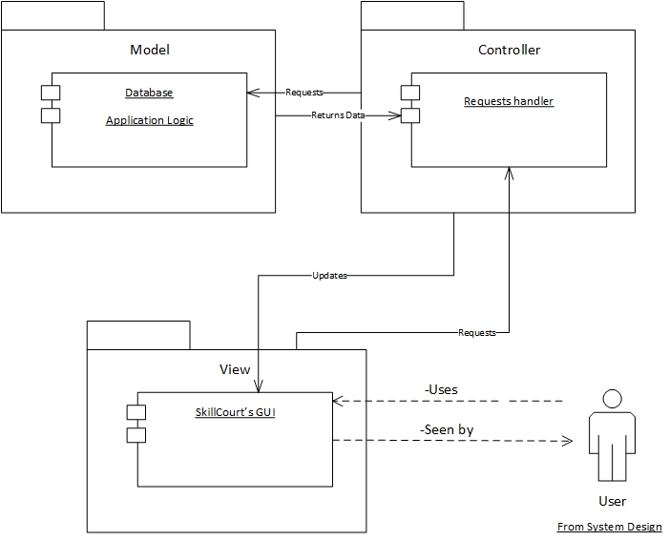

*Figure #1 – Model-View-Controller (MVC) Architecture*

## System and Subsystem Decomposition

SkillCourt is conformed of three major subsystems, each of them offering different functionalities. Below is a brief description of their functionality, followed by a UML package diagram that describes the system.

* **SkillCourt Website:** The first subsystem is a website that allows users to view & edit their account information, view & play custom & default routines assigned by their personal coach and play any of the seven predefined routines. The website’s purpose is to provide a proof-of-concept of what the new SkillCourt training methodology is about. The website also provides coaches to login and create, edit, delete and assign routines to their players. The website also contains the following subsystems:
  + **Online Simulator:** The online simulator allows users to play custom and default assigned routines, as well as pre designed routines. It also provides players with live statistic feedback about their performance in the current game. The class diagram for this subsystem was developed using UML and represents the classes needed to implement it (Refer to Appendix A).
  + **Online Wizard:** As the second subsystem of the website, the Online Wizard allows coaches to create custom routines, as well as edit previously existing custom routines. The class diagram for this subsystem was developed using UML and represents the classes needed to implement it (Refer to Appendix A).
  + **Account Management:** This subsystem provides the user the ability to view & edit their personal and account information like first name, middle name, last name, gender, birthdate, username, password email address and coach information, if any.
  + **Routine Management:** The routine management is designed to work for players and coaches, and both have different functionalities. The coach has the ability to sign & release a player, as well as assign & unassign routines to their players. In this subsystem, the player has the ability to view & play the assigned default or custom routines.
* **Android Application**: The second subsystem is an Android Mobile Application that allows users to play new routines on the desktop simulator via the Arduino Controller. The User Interface and application logic were modified to adapt to the new simulator upgrades.
* **Desktop Simulator**: As a third subsystem, the desktop simulator allows a user to play a default routine selected in the Android Application. The desktop simulator was upgraded to add Time per Round game type, an option to remove a wall and ability to use the Ground Pads.

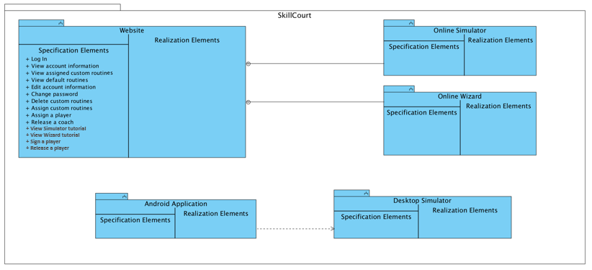

*Figure #2 - System & Subsystem Package Diagram*

## Deployment Diagram

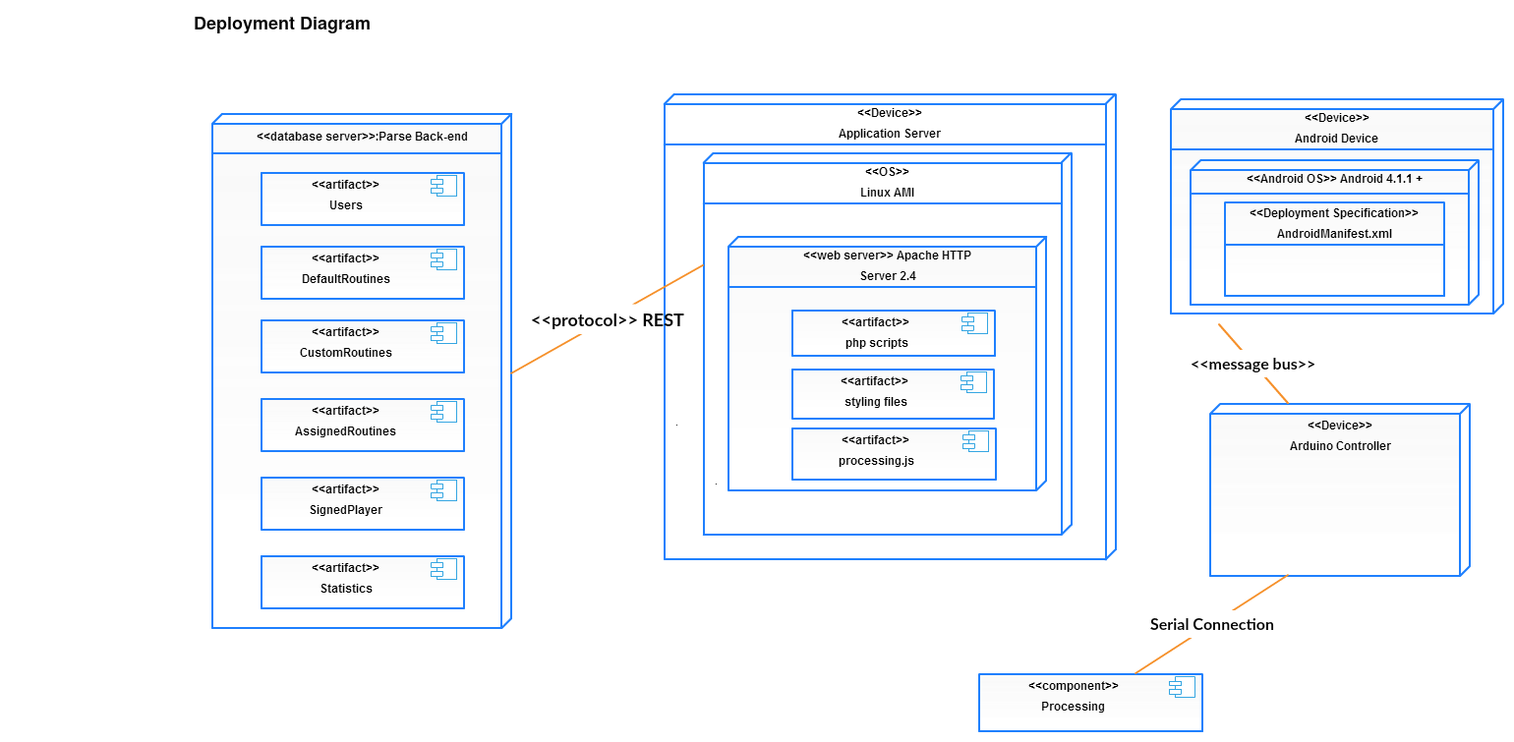Using a UML deployment diagram, illustrate which subsystems will reside on each hardware component and show how the different pieces are connected.

*Figure #3 - SkillCourt Deployment Diagram*

## Design Patterns

The subsystem that contains the mobile application, desktop simulator, and Arduino controller was built using MVC architecture (Figure 4). This simplifies the role of each member and keeps their functionality organized.

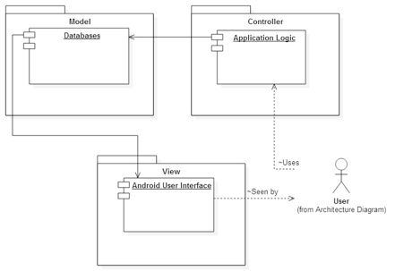

*Figure #4 - MVC Design Patter*

# System Validation

The following section provides a detailed list of all the system validation scenarios that were performed on the system. The system validation is divided by each implement user story.

**User Story #2 - Interactive Summary Table**

|  |  |
| --- | --- |
| **Test Case ID:** | **Summary_Table_1** |
| **Purpose:** | **Test that a user is able change between tabs** |
| **Prerequisite:** | **User accesses the website homepage** |
| **Test Data** | **None** |
| **Steps:** | **1. User clicks on SkillCourt tab**  **2. User clicks on Live Demo tab**  **3. User clicks on Player tab**  **4. User clicks on Coach tab**  **5. User clicks on Simulator tab**  **6. User clicks on Routine Wizard tab** |
| **Expected Results:** | **The interactive summary table changes to displays corresponding information** |
| **Actual Results:** | **As expected** |

|  |  |
| --- | --- |
| **Test Case ID:** | **Summary_Table_2** |
| **Purpose:** | **Test that video pauses when user changes tab** |
| **Prerequisite:** | **User accesses the website homepage** |
| **Test Data** | **None** |
| **Steps:** | **1. User clicks on SkillCourt tab**  **2. User clicks on Live Demo tab** |
| **Expected Results:** | **Video passes when clicking in another tab and resumes when going back to Live Demo tab** |
| **Actual Results:** | **As expected** |

**User Story #3 - Player Tutorial Interactive Guide**

|  |  |
| --- | --- |
| **Test Case ID:** | **Player_Tutorial_1** |
| **Purpose:** | **Test that simulator tutorial starts when user clicks on Help** |
| **Prerequisite:** | **User has logged in as player**  **User is in the simulator view** |
| **Test Data** | **None** |
| **Steps:** | **1. User clicks on the Help tab**  **2. User goes over the tutorial steps** |
| **Expected Results:** | **Simulator Tutorial Guide starts with the corresponding steps** |
| **Actual Results:** | **As expected** |

|  |  |
| --- | --- |
| **Test Case ID:** | **Player_Tutorial_2** |
| **Purpose:** | **Test that no actions can be done outside the tutorial until done or skipped** |
| **Prerequisite:** | **User has logged in as player**  **User is in the simulator view**  **User has started the simulator interactive tutorial** |
| **Test Data** | **None** |
| **Steps:** | **1. User clicks on Play while the tutorial is active**  **2. User clicks to change an option in the phone layout** |
| **Expected Results:** | **Simulator Tutorial blocks any action that is not related to the tutorial** |
| **Actual Results:** | **As expected** |

**User Story #4 - Coach Tutorial Interactive Guide**

|  |  |
| --- | --- |
| **Test Case ID:** | **Coach_Tutorial_1** |
| **Purpose:** | **Test that wizard tutorial starts when user clicks on Help** |
| **Prerequisite:** | **User has logged in as coach**  **User is in the wizard view** |
| **Test Data** | **None** |
| **Steps:** | **1. User clicks on the Help tab**  **2. User goes over the tutorial steps** |
| **Expected Results:** | **Wizard Tutorial Guide starts with the corresponding steps** |
| **Actual Results:** | **As expected** |

|  |  |
| --- | --- |
| **Test Case ID:** | **Coach_Tutorial_2** |
| **Purpose:** | **Test that no actions can be done outside the tutorial until done or skipped** |
| **Prerequisite:** | **User has logged in as coach**  **User is in the wizard view**  **User has started the simulator interactive tutorial** |
| **Test Data** | **None** |
| **Steps:** | **1. User clicks add routine while the tutorial is active**  **2. User clicks to change to default routines in the wizard settings** |
| **Expected Results:** | **Simulator Tutorial blocks any action that is not related to the tutorial** |
| **Actual Results:** | **As expected** |

**User Story #5 - Enhance About Page**

|  |  |
| --- | --- |
| **Test Case ID:** | **About_Page_1** |
| **Purpose:** | **Test that layout is does not overlaps with other elements when resizing the window** |
| **Prerequisite:** | **User accesses the website about page** |
| **Test Data** | **None** |
| **Steps:** | **1. User resizes the browser window to many sizes.** |
| **Expected Results:** | **Help page layout and format is persistent and rescales elements to fit nicely in the window size presented by the user** |
| **Actual Results:** | **As expected** |

**User Story #7 - Interactive Team Members Display**

|  |  |
| --- | --- |
| **Test Case ID:** | **Team_Display_1** |
| **Purpose:** | **Test that interactive displays changes when used the next and previous buttons** |
| **Prerequisite:** | **User accesses the website about page** |
| **Test Data** | **None** |
| **Steps:** | **1. User clicks next button to move to another team member**  **2. User clicks on previous button to return to previous team member** |
| **Expected Results:** | **Interactive displays changes accordingly displaying next and previous team member** |
| **Actual Results:** | **As expected** |

**User Story #10 – Help Button Interaction**

|  |  |
| --- | --- |
| **Test Case ID:** | **Help_Button_1** |
| **Purpose:** | **Test that help button starts corresponding tutorial about custom and default routine creation** |
| **Prerequisite:** | **User has logged in as coach**  **User is in the wizard view** |
| **Test Data** | **None** |
| **Steps:** | **1. User clicks on custom and clicks on Help**  **2. User goes over wizard custom tutorial**  **3. User changes to default routines and clicks on Help**  **4. User goes over wizard default tutorial** |
| **Expected Results:** | **Wizard interactive tutorial displays the correct steps when user is at the custom and default routine creation view** |
| **Actual Results:** | **As expected** |

**User Story #20 - Allow Coach users to edit created routines**

|  |  |
| --- | --- |
| **Test Case ID:** | **Test that a user is able to edit routines** |
| **Purpose:** | **Test that a Coach user is able to edit routines** |
| **Prerequisite:** | **User accesses the website homepage as a Coach user.** |
| **Test Data** | **None** |
| **Steps:** | 1. **The user clicks on the Routines page** 2. **The user clicks on a routine** 3. **The user clicks on the edit button** 4. **The user add an additional step or changes an existing step** 5. **The user clicks on the finish editing button** |
| **Expected Results:** | **When the user clicks on the edit button it will redirect the user to the Wizard page. Then the user will complete editing the routine and the system will redirect the user to the Routines page.** |
| **Actual Results:** | **As expected** |

**User Story #21 - Allow Coach users to delete unassigned created routine**

|  |  |
| --- | --- |
| **Test Case ID:** | **Test that a user is able delete routines** |
| **Purpose:** | **Test that a Coach user is able to delete routines** |
| **Prerequisite:** | **User accesses the website homepage as a coach user, and the routine has no assigned players.** |
| **Test Data** | **None** |
| **Steps:** | 1. **User accesses the Routines page** 2. **User clicks on a routine with no assigned players** 3. **User clicks the delete button** 4. **User confirms its action by clicking accept** |
| **Expected Results:** | **The page will process the user’s request and it will reload the list and show reflect the deleted routine** |
| **Actual Results:** | **As expected** |

**User Story #17 - Allow Coach users to release players from the search results page**

|  |  |
| --- | --- |
| **Test Case ID:** | **Test that a user is able to release signed players** |
| **Purpose:** | **Test that a Coach user is able to release previously signed players** |
| **Prerequisite:** | **User accesses the website homepage and logs in as a Coach** |
| **Test Data** | **None** |
| **Steps:** | 1. **User clicks on the Players page** 2. **User searches for his Players** 3. **User clicks on the search button** 4. **User select a player’s row** 5. **User clicks the RELS button** |
| **Expected Results:** | **The page will reload and the user’s status will change to free.** |
| **Actual Results:** | **As expected** |

**User Story #19 – Allow Player users to play custom/default routines.**

|  |  |
| --- | --- |
| **Test Case ID:** | **Test that a user is able to play custom and default routines** |
| **Purpose:** | **Test that a player user is able to play either custom or default routines** |
| **Prerequisite:** | **User accesses the website homepage and logs in as a Player** |
| **Test Data** | **None** |
| **Steps:** | 1. **User clicks on the Simulator page** 2. **User clicks on the simulator and chooses a routine** 3. **User clicks the play button** 4. **User plays with the simulator** |
| **Expected Results:** | **The system returns the user a clickable simulator displaying the selected routine’s steps** |
| **Actual Results:** | **As expected** |

**User Story #22 - Allow Coach users to create custom/default routines**

|  |  |
| --- | --- |
| **Test Case ID:** | **Test that a user is able to create routines** |
| **Purpose:** | **Test that a Coach user is able to create routines** |
| **Prerequisite:** | **User accesses the website homepage and logs in as a Coach** |
| **Test Data** | **None** |
| **Steps:** | 1. **User clicks on the Wizard page** 2. **User completes steps and rounds** 3. **User clicks finish routine** 4. **User enters a name and a description** 5. **User clicks the finish button** |
| **Expected Results:** | **The user is redirected to the Routines page and the newly created routine iis displayed on the list of routines** |
| **Actual Results:** | **As expected** |

**User Story #15 - Allow Coach users to search for players using filters**

|  |  |
| --- | --- |
| **Test Case ID:** | **Test that a user is able to search for players using filters** |
| **Purpose:** | **Test that the system returns the correct players based on the input criteria** |
| **Prerequisite:** | **User accesses the website homepage and logs in as a Coach** |
| **Test Data** | **None** |
| **Steps:** | 1. **User clicks on the Players page** 2. **User clicks on the Sign/Release players pill (button)** 3. **User clicks on the filter by button** 4. **User chooses position, and attacking midfielder** 5. **User clicks on the search button** |
| **Expected Results:** | **The system will return all the players that match the given criteria.** |
| **Actual Results:** | **As expected** |

**User Story #18 - Allow Coach users to assign routines to signed Players**

|  |  |
| --- | --- |
| **Test Case ID:** | **Test that a user is able to assign routines to signed players** |
| **Purpose:** | **Test that a coach is able to assign routines without any errors** |
| **Prerequisite:** | **User accesses the website homepage and logs in as a coach** |
| **Test Data** | **None** |
| **Steps:** | 1. **User clicks on the Routines tab** 2. **User clicks on a routine from the routines list** 3. **User clicks on the assign button** 4. **User clicks on a user** 5. **User clicks on the assign button in the modal** |
| **Expected Results:** | **The modal screen closes and the list of assigned players gets updated** |
| **Actual Results:** | **As expected** |

**User Story #12 – Allow Users to add favorite soccer teams**

|  |  |
| --- | --- |
| **Test Case ID:** | **Test that a user is able to add their favorite soccer teams** |
| **Purpose:** | **Test that a user is able to save their entered favorite teams** |
| **Prerequisite:** | **User accesses the website and logs in** |
| **Test Data** | **None** |
| **Steps:** | 1. **User clicks on the their username in the top navbar** 2. **User clicks on the settings tab** 3. **Use clicks on the Various Info tab** 4. **User types a team’s name, and clicks on add another team** 5. **Enter this information** 6. **Clicks on the save button** |
| **Expected Results:** | **The page reloads, and the newly added soccer teams are displayed on the user’s profile pane** |
| **Actual Results:** | **As expected** |

# Glossary

|  |  |
| --- | --- |
| App | Refers to the SkillCourt Application in the Mobile Device |
| Pad Simulator | An emulated device which will take the place of SkillCourt pads for testing showcasing purposes. This device will offer all of the features a SkillCourt Pad will offer |
| SkillCourt | A system which uses SkillCourt Pads and a player interface for training soccer |
| SkillCourt Room | A 20’x40’ room with SkillCourt Pads on the walls used for soccer training. |
| SkillCourt Pad | A physical device with a flat surface that can measure and transmit when and how much pressure it received |
| Class Diagram | A pictorial representation of all the classes in the system |
| Object Diagram | A pictorial representation of an instance of a class with example of how the data of the class will be populated |
| Sequence Diagram: | A pictorial representation of how processes operate with one another and the user during the course of a specific piece of functionality. |
| Use Case | List of steps defining the interaction between the user and the system to achieve a goal |
| Online Wizard | Refers to a simulation of a SkillCourt room that allows a coach to design custom routines. |

# Appendix

## Appendix A - UML Diagrams

### Static UML Diagrams

### 

### Figure #5 - Online Simulator Class Diagram

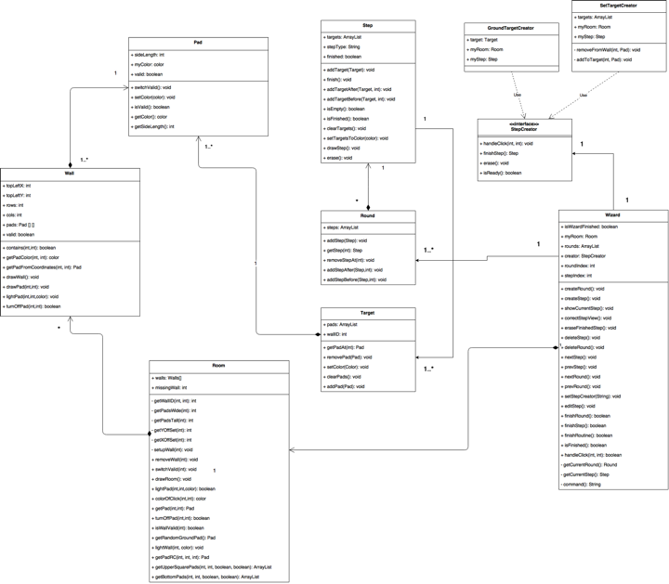

### 

### Figure #6 - Online Wizard Class Diagram

### C:\Users\SLS\AppData\Local\Microsoft\Windows\INetCache\Content.Word\ClassDiagramSprint7.jpg

### Figure #7 – Online Routine Class Diagram

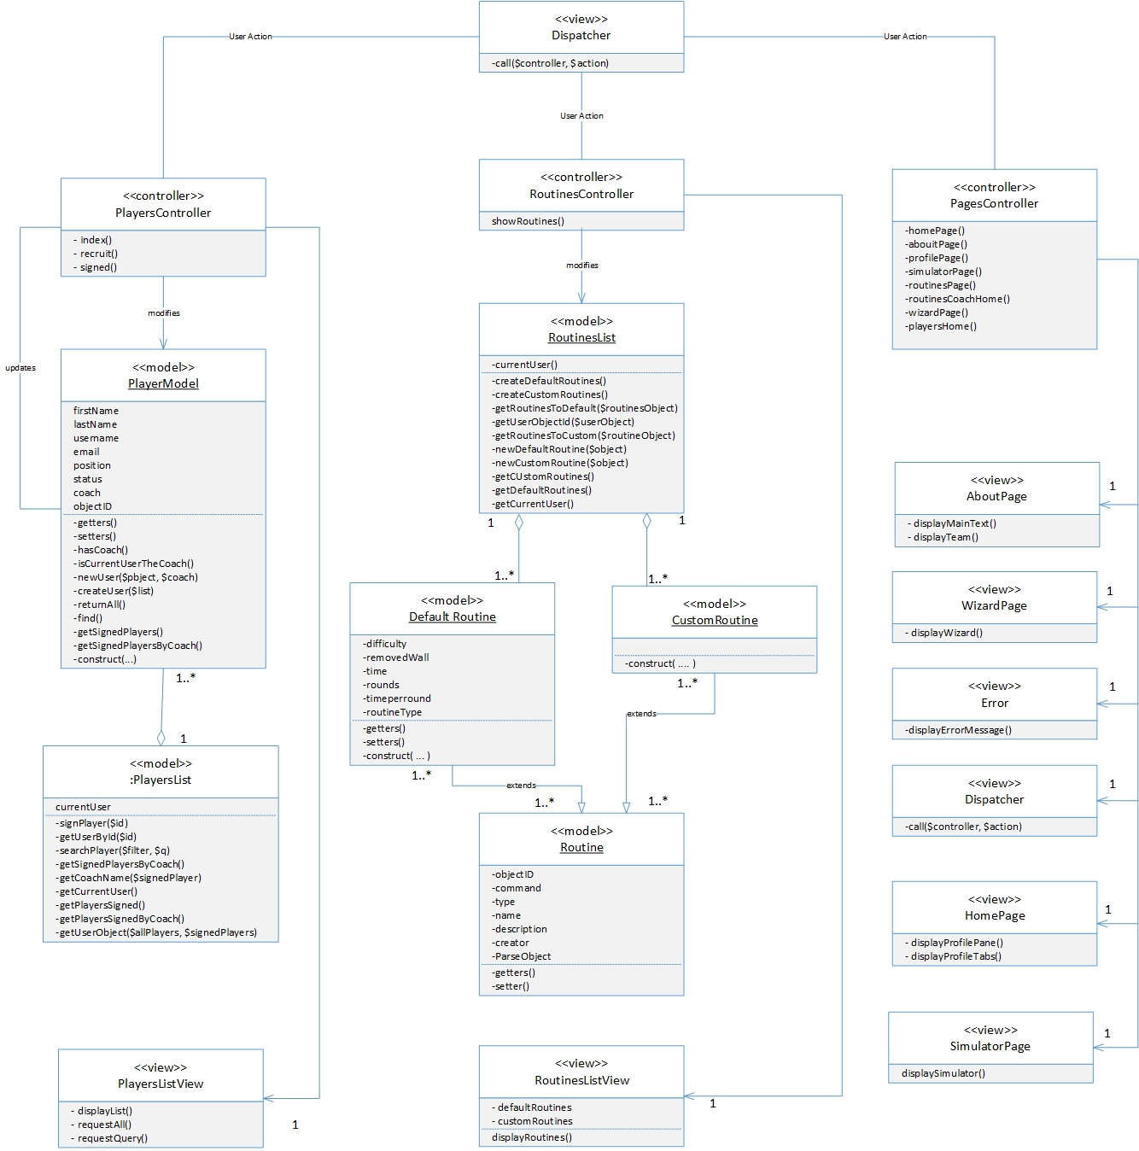

*Figure #8 – SkillCourt Object Design*

### Dynamic UML Diagrams

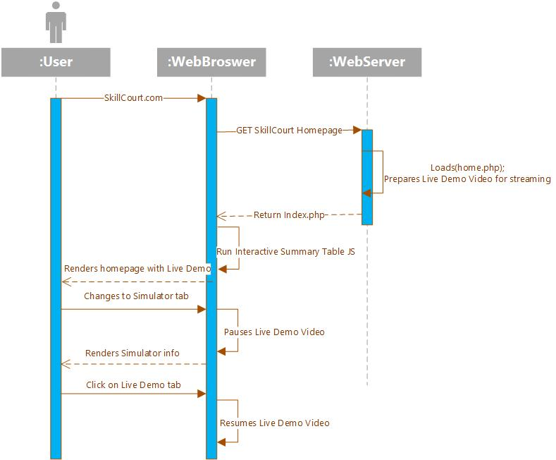

### 

### 

### 

### 

### 

### 

### 

### 

*Figure #9 – Interactive Summary Table Sequence Diagram*

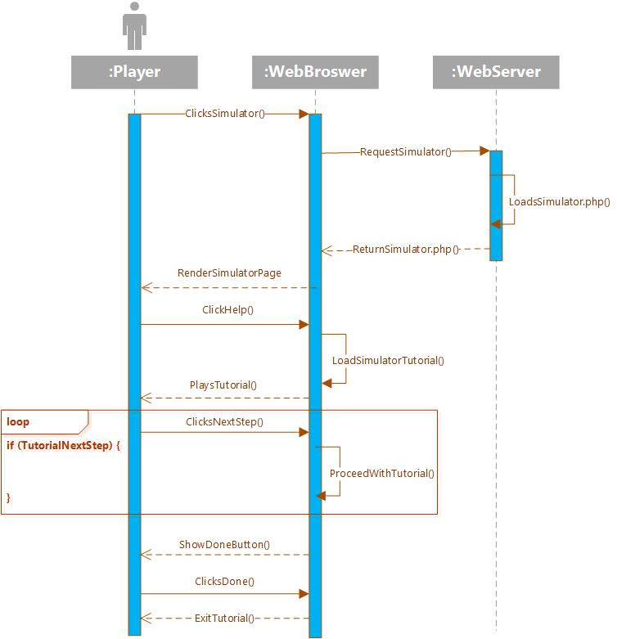

*Figure #10 – Player Tutorial Interactive Guide Sequence Diagram*

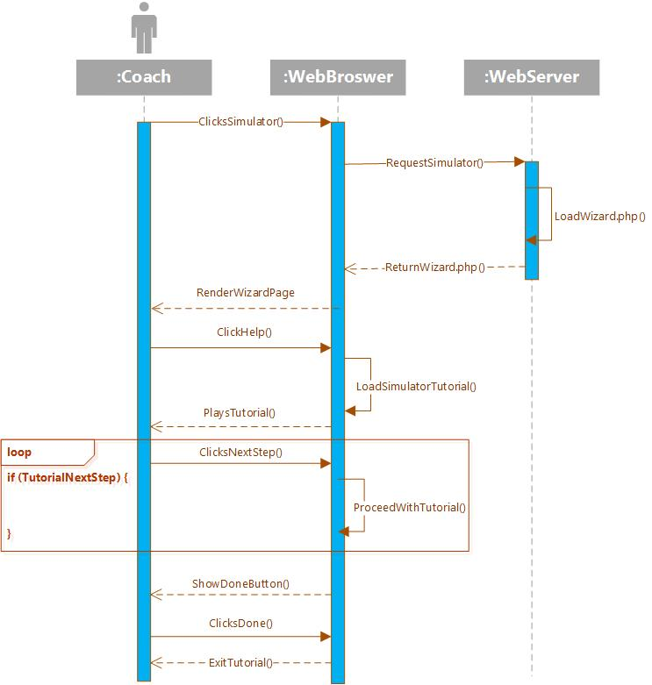

*Figure #11 – Coach Tutorial Interactive Guide Sequence Diagram*

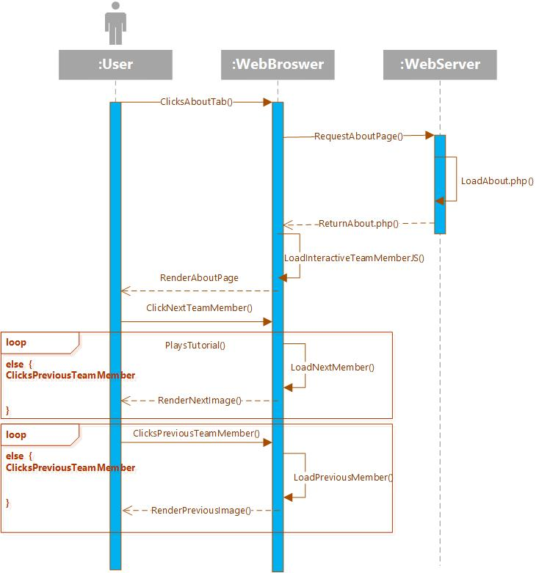

*Figure #12 – Interactive Team Member Display Sequence Diagram*

### 

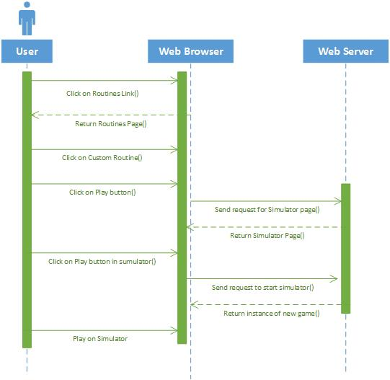

*Figure #13 – User Player Routine Sequence Diagram*

### 

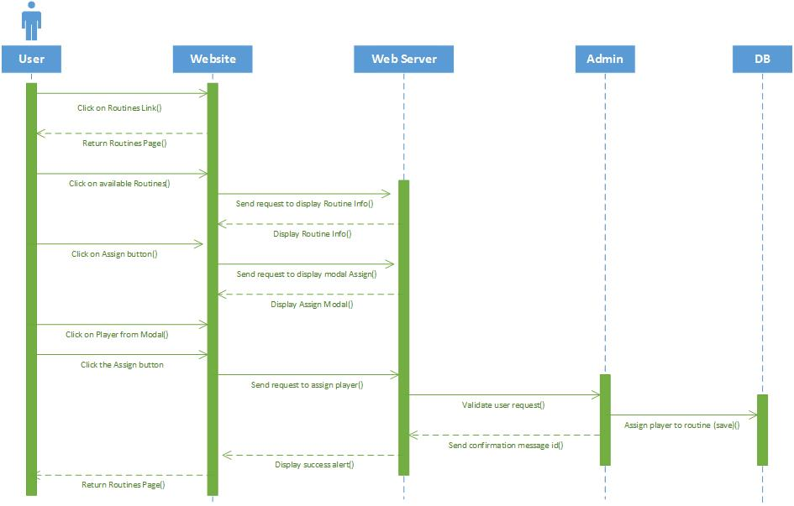

*Figure #14 – User Coach Routine Sequence Diagram*

### 

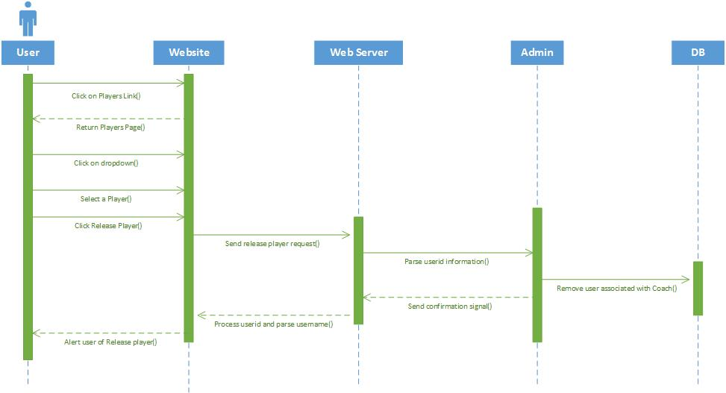

*Figure #14 –Coach Mode Player Page Sequence Diagram*

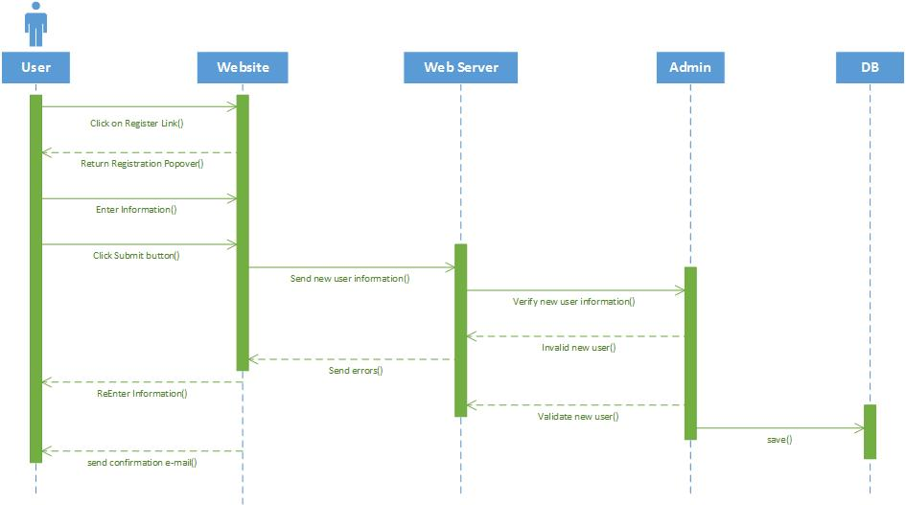

*Figure #15 – User Registration Sequence Diagram*

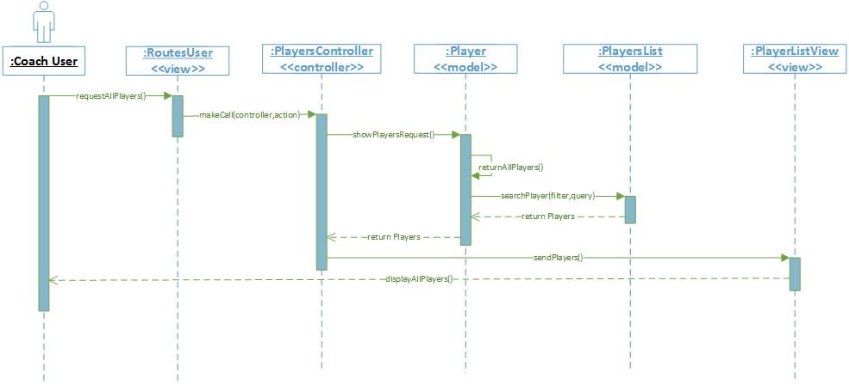

*Figure #16 – Coach All Player Request Sequence Diagram*

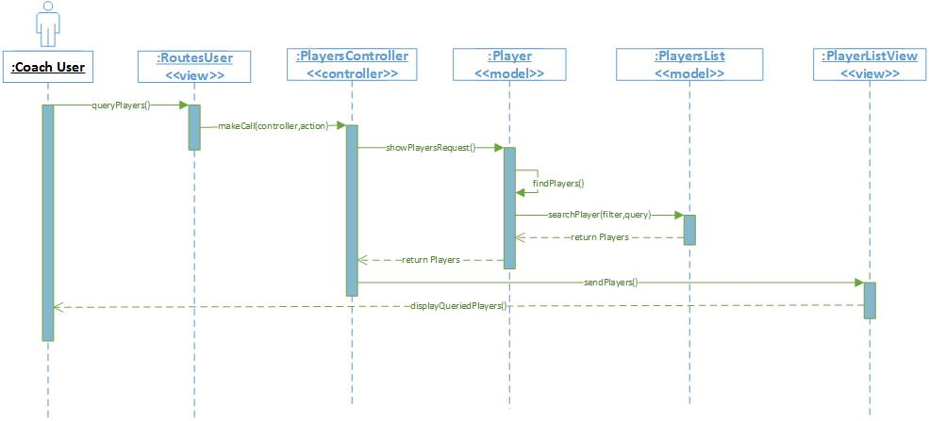

*Figure #17 – Coach Query Player Sequence Diagram*

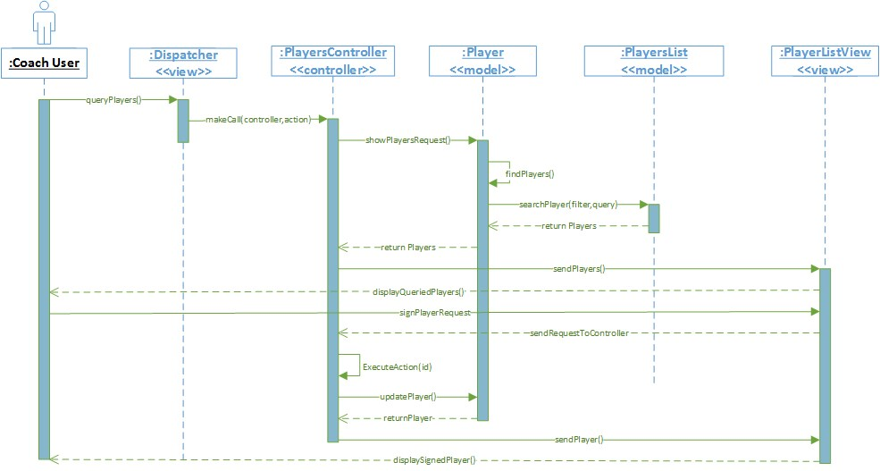

*Figure #18 – Coach Sign Player Sequence Diagram*

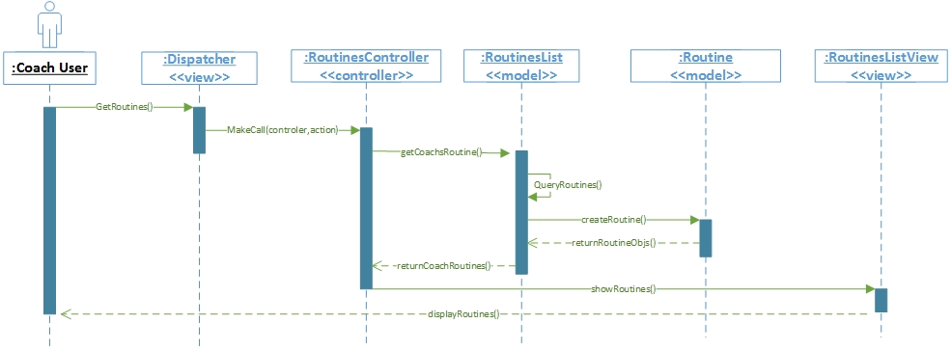

*Figure #19 – Coach Assign Routine Sequence Diagram*

## Appendix B - User Interface Design

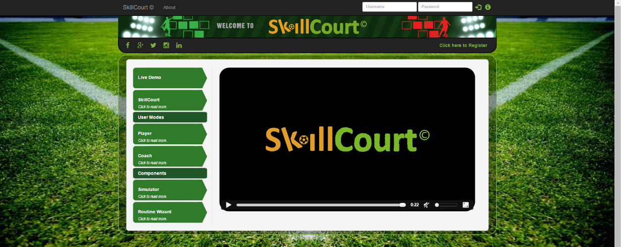

*Figure #20 – SkillCourt Homepage*

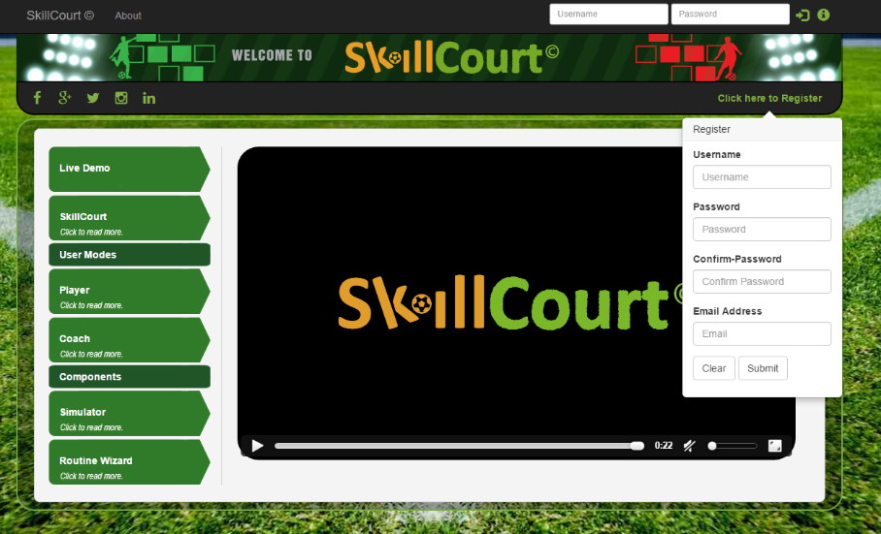

*Figure #21 – User Registration*

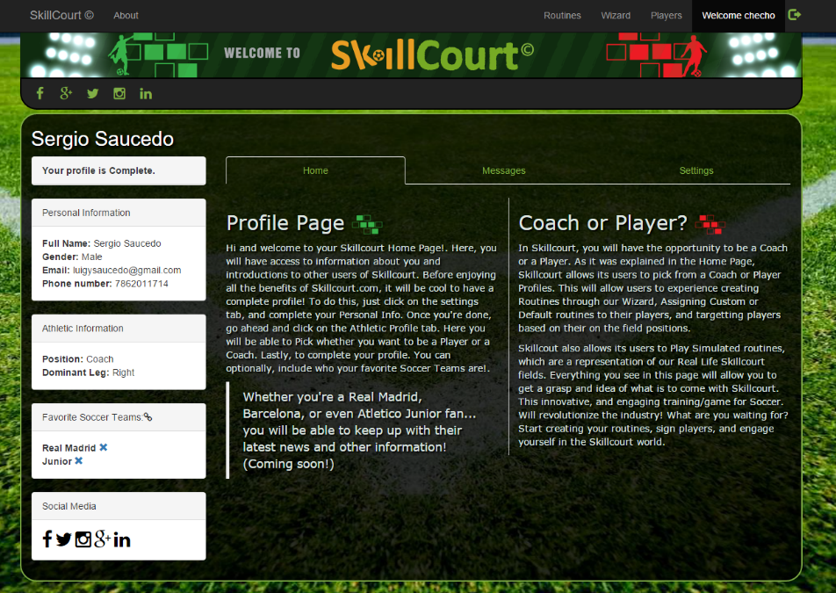

*Figure #22 – Coach Profile View*

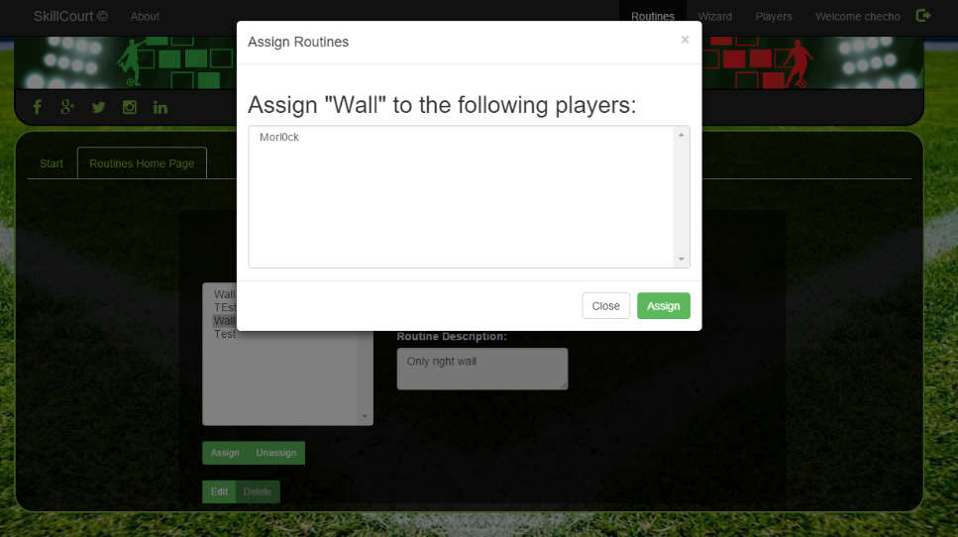

*Figure #23 – Coach Routine Assignment*

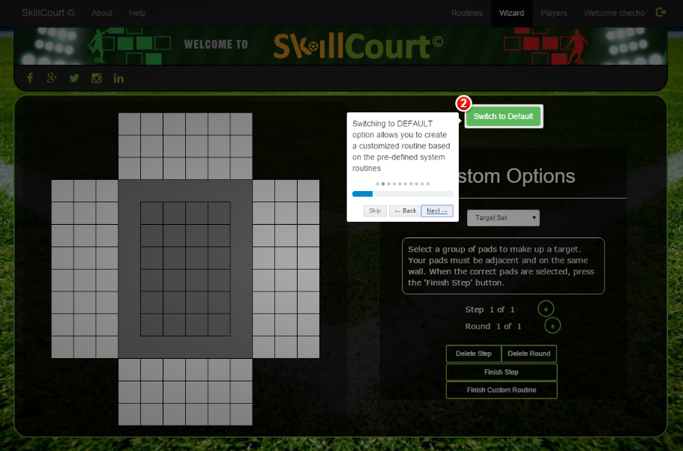

*Figure #24 – Wizard Interactive Tutorial*

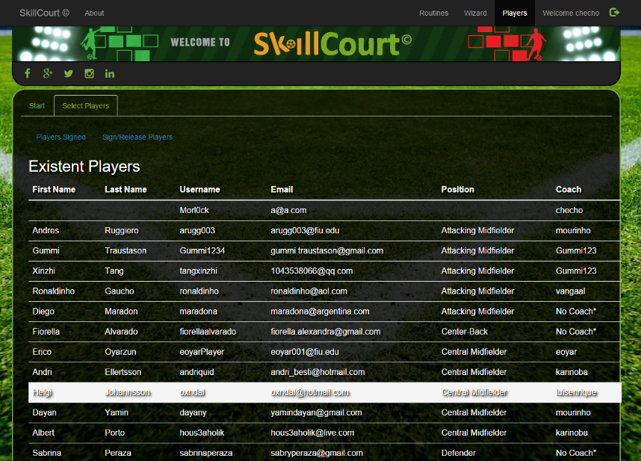

*Figure #25 – Coach Mode Existent Players*

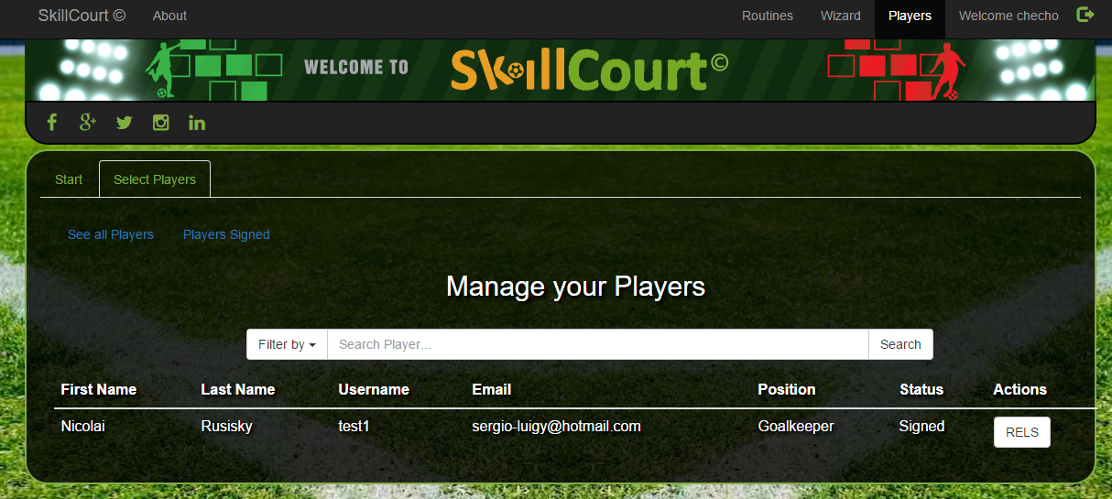

*Figure #26 – Coach Signing Player*

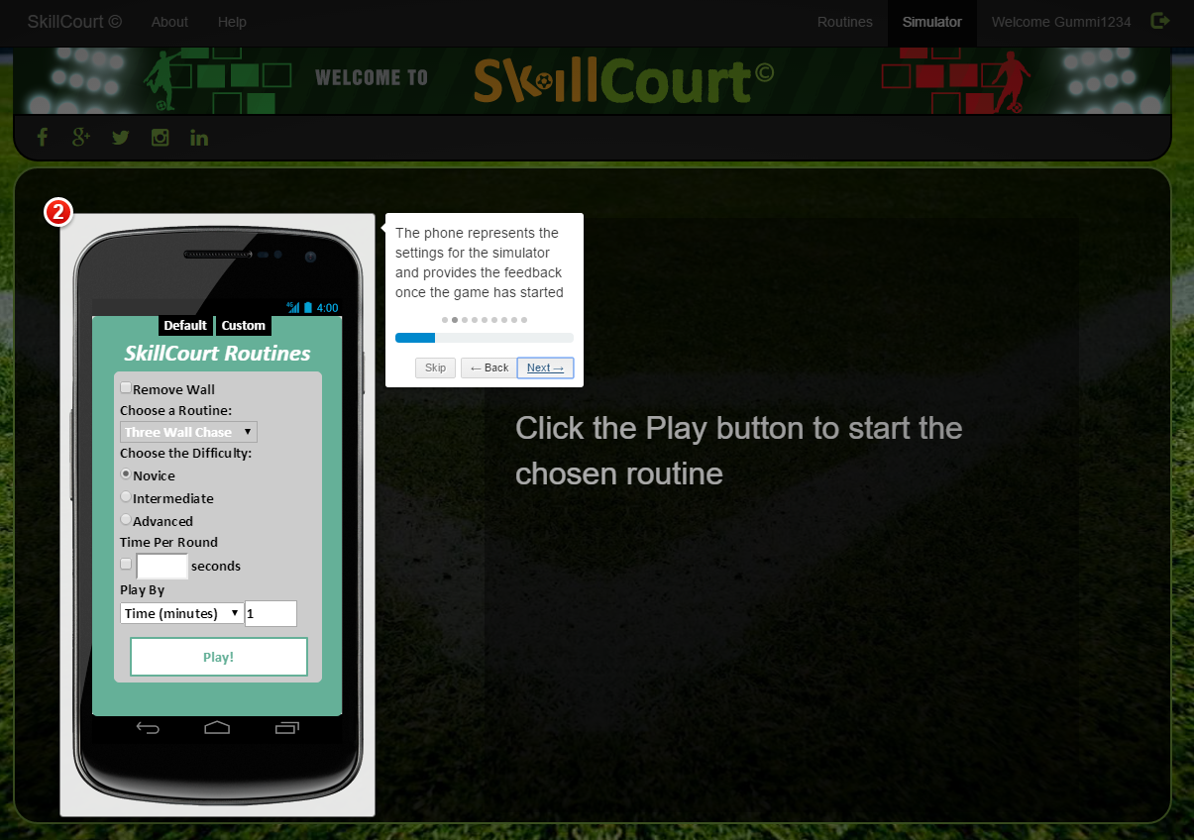

*Figure #27 – Simulator Interactive Tutorial*

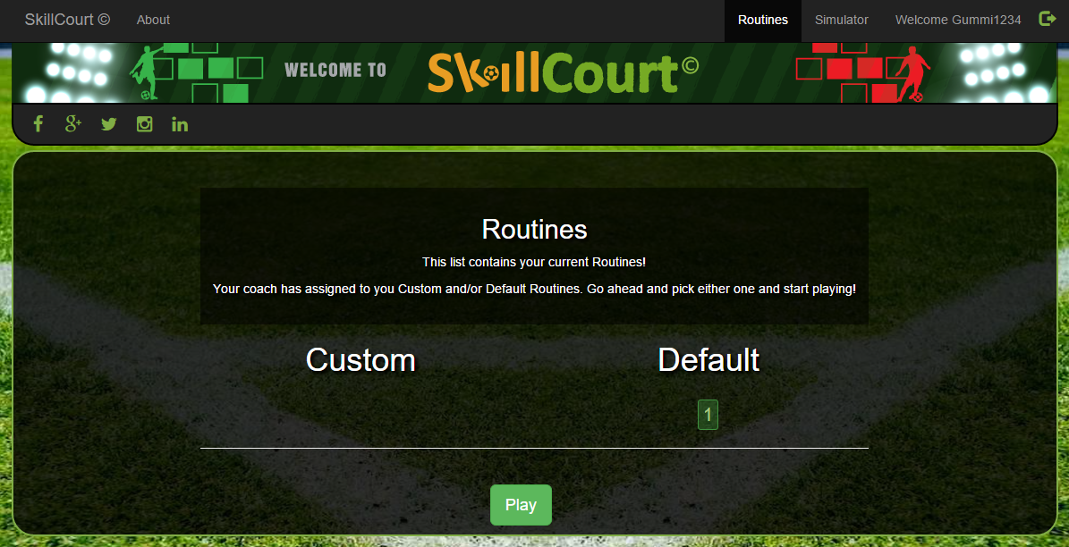

*Figure #28 – Player Routine Selection*

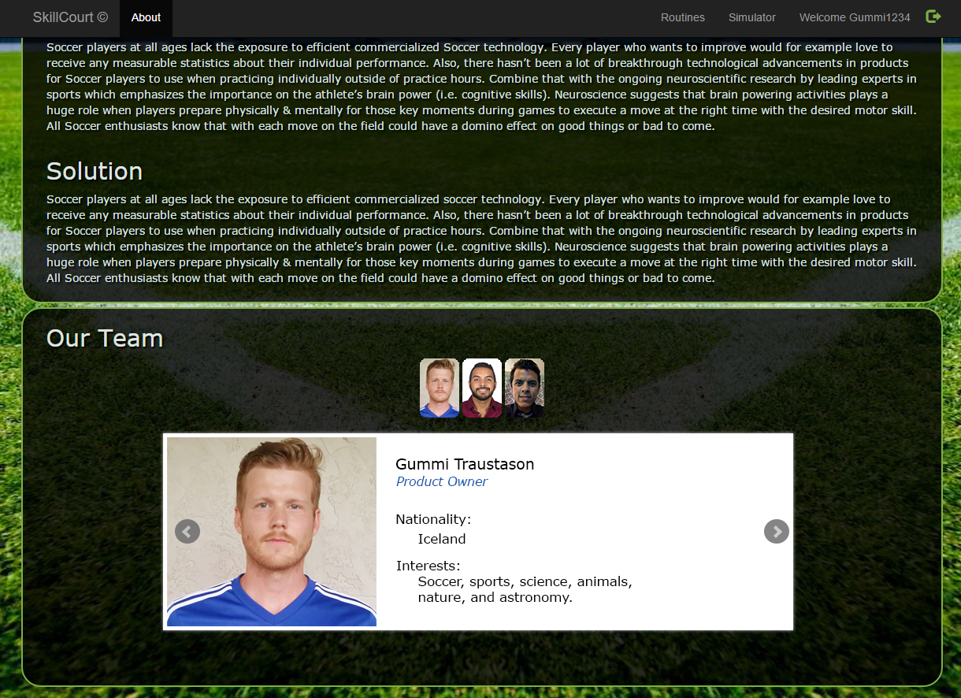

*Figure #29 – Interactive Team Member Display*

## Appendix C - Sprint Review Reports

**Sprint 1 Report**

**Date:** September 11, 2015

**Attendees:** Masoud Sadjadi, Gummi Traustason, Sergio Saucedo, Will Rodriguez

**Discussed Topics:**

During this sprint, we weren’t able to make much progress in regards to user stories as there were some setbacks in meeting the product owners. We did familiarized ourselves with the system and how it was developed by playing with the functionalities on the websites. We were able to log several bugs.

**Sprint 2 Report**

**Date:** September 25, 2015

**Attendees:** Masoud Sadjadi, Gummi Traustason, Sergio Saucedo, Will Rodriguez

**Discussed Topics:**

For this sprint we were able to come up with the main user stories after our first meeting with the product owner. Having understood the initial requirement and how Gummi envisioned SkillCourt, we focused on working on improving the user experience. We started working on the new UI design that was agreed by Gummi and to refactor the SkillCourt Homepage. Since, three was no enough time, improving the homepage was added to the backlog as it required too the implementation of interactive content.

**Sprint 3 Report**

**Date:** October 9, 2015

**Attendees:** Masoud Sadjadi, Gummi Traustason, Sergio Saucedo, Will Rodriguez

**Discussed Topics:**

The purpose of this sprint was to get started implementing new features. Redesigning the website into a MVC architecture and developing the interactive features started. We were able to finish most of the user stories such as filming the SkillCourt Live Demo video and adding new logic to setting page, and creation of user profile page. A few user stories made into the product backlog as it took us more time that we had planned in the user stories that we worked on.

**Sprint 4 Report**

**Date:** October 23, 2015

**Attendees:** Masoud Sadjadi, Gummi Traustason, Jaime Borras, Sergio Saucedo, Will Rodriguez

**Discussed Topics:**

During this sprint, homepage was almost completed with the implementation of the interactive content and with the edited live demo fused together. This sprint saw the most user stories completed in term of the redesigning the architecture into a MVC pattern. Registrations were improved and implemented, and new features were added like changing from coach to player and vice versa. Improvement were started in the about page which also is going to have interactive content.

**Sprint 5 Report**

**Date:** November 6, 2015

**Attendees:** Masoud Sadjadi, Gummi Traustason, Jaime Borras, Sergio Saucedo, Will Rodriguez

**Discussed Topics:**

During these sprint, focused was given to documentation. User cases and sequence diagrams were created for the user stories that are going to be worked on in the upcoming sprints. Home and About page was filled with actual information and confirmed by the product owner. Most of the stories that were put in the backlog had been developed by now.

**Sprint 6 Report**

**Date:** November 20, 2015

**Attendees:** Masoud Sadjadi, Gummi Traustason, Jaime Borras, Sergio Saucedo, Will Rodriguez

**Discussed Topics:**

With the proper documentation created, in the previous sprint, implementation of the remaining main stories was clearer. Interactive tutorial for the simulator was completed and tested. Some modifications from product owners’ feedback were done regarding the homepage live demo. By this sprint, coaches are able to sing and release players and the list of players signed can be query

**Sprint 7 Report**

**Date:** December 4, 2015

**Attendees:** Masoud Sadjadi, Gummi Traustason, Jaime Borras, Sergio Saucedo, Will Rodriguez

**Discussed Topics:**

By this sprint, all the major user stories that were planned from the beginning are all completed. The interactive tutorial for the wizard was finished explaining step by steps when creating a custom or default routine. Minor changes were completed as well, to give SkillCourt the consistency across the user interface theme used. New logo was designed and video of updated with it. Some stories that were backlog from previous release were completed such as having a ball as the screen pointer in the simulator. Coach features were finalized in terms on assigning and retrieving routines.

## Appendix D - Sprint Retrospective Reports

**Sprint 1 Retrospective**

**Date:** September 11, 2015

**Attendees:** Wil Rodriguez, Sergio Saucedo

**Discussed Topics:**

Things that went not so well was agreeing with product owners for meetings. That set us back to begin the collection of user stories as we couldn’t ‘meet for the initial requirements. We did use this time to familiarize ourselves with the website and how it was developed.

**Sprint 2 Retrospective**

**Date: September 25, 2015**

**Attendees:** Wil Rodriguez, Sergio Saucedo

**Discussed Topics:**

Things that went well included the goals that the product owner had for this semester. We were able to gather the main user stories set to be done until SkillCourt release. We had some setback agreeing with a meeting, but we were able to fix this issue by keeping in contact with a messaging service.

**Sprint 3 Retrospective**

**Date: October 9, 2015**

**Attendees:** Wil Rodriguez, Sergio Saucedo

**Discussed Topics:**

Progress was made on this sprint. We started working on implementing new user interfaces and features for both players and coach users. Some things were challenging as PHP was not our forte, but were able to still implement some features by doing research.

**Sprint 4 Retrospective**

**Date: October 23, 2015**

**Attendees:** Wil Rodriguez, Sergio Saucedo

**Discussed Topics:**

This sprint was the one where we made more progress in term of implementing different user stories. Redesigning the website in to a MVC architecture allowed us to work simultaneously in user interfaces and codebase. This sprint was overall good, but when it came to the sprint review, documentation was not so great.

**Sprint 5 Retrospective**

**Date: November 6, 2015**

**Attendees:** Wil Rodriguez, Sergio Saucedo

**Discussed Topics:**

Upcoming user stories from this sprint on were carefully planned and documented. This allows us to work more efficiently and implement features faster. The product backlog was reduced as we were able to fix several bugs in the implementations of certain features concerning the codebase and user interfaces.

**Sprint 6 Retrospective**

**Date: November 20, 2015**

**Attendees:** Wil Rodriguez, Sergio Saucedo

**Discussed Topics:**

Interactive tutorial for the simulator was completed and coach users are now able to sign and release players. We were coming to an end with the last user stories we set to implement on this release.

**Sprint 7 Retrospective**

**Date: December 4, 2015**

**Attendees:** Wil Rodriguez, Sergio Saucedo

**Discussed Topics:**

The user stories for Sprint 7 were all completed, without affecting the product backlog. We have a final product that we are all proud about. Product owners were happy with the result. The only thing that got missing, was the work for the mobile application, as a change of focus occurred at the very last. We got to work on the implementation of the first pressure pad which we will be able to show off at the showcase.

# References

You must reference any work that is not your own.

* <http://www.w3schools.com/>
* [The Fundamental Theorem of Agile Software Development](https://moodle.cis.fiu.edu/v2.8/mod/url/view.php?id=36850)

By J. B. Rainsberger

* help.github.com